Below Ground Utilities Survey – Field H 1550 (N) & (S)
Encompass Surveys

Description of the works:
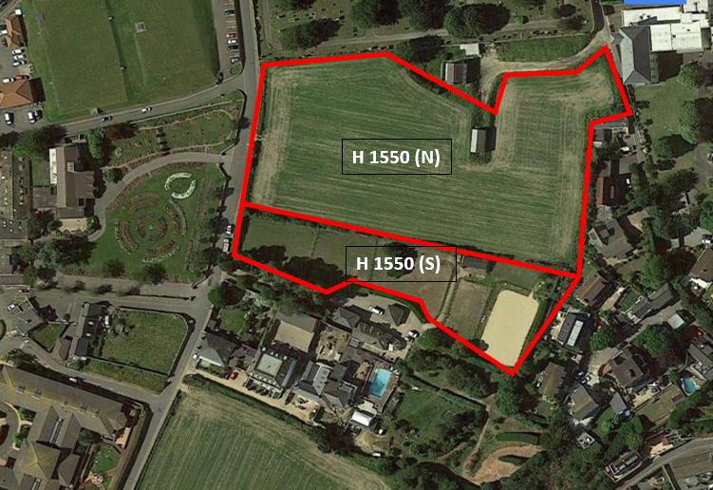
We would like to carry out a utilities survey to identify any below ground services within field H1550 adjacent to the Overdale site. The survey works include scanning the ground with a ground penetrating radar to determine any live services beneath the ground with a locator tool to determine the type of service located. A ground penetrating radar is a machine that scans the ground to collect data which is then processed in the office. As part of the survey any manhole covers in the field will need to be temporarily lifted to trace ducts and drainage pipes using flexi-trace/sonde detection. The utilities survey will be non-intrusive and carried out using a Leica Ultra Locator to identify any cables/pipes. Any services discovered will be marked on the ground using a removable spray paint and then measured using GPS/Total Station.
Fig. 01

Encompass Surveying will conduct their survey in accordance to their risk assessment and method statements under strict COVID-19 guidelines. All surveyors will be wearing 4 point PPE, hardhats, high-visibility jackets and steel toe capped boots along with a face mask at all times.

Number of personnel:
We will have 2 survey teams on site (total of 4 surveyors). David Sweeney will be the lead surveyor on site accompanied by 3 surveyors. All personnel will adhere to social distancing to members of the public and be wearing masks throughout the entirety of the survey. All the operatives have been properly briefed and fully understand the code of conduct they must adhere to when working on privately owned land. There will be an allocated parking and welfare facilities for the surveyors to use within the Overdale site. All operatives will have a full health and safety induction by the ROKFCC Health & Safety Manager, and ensure that all COVID-19 guidelines are adhered to throughout.

Duration of the works:
The duration of the Survey in Field H 1550 (N) will take approx. 1 week.
The duration of the Survey in Field H 1550 (S) will take approx. 1 week.

